**Database:** BCMPLIB

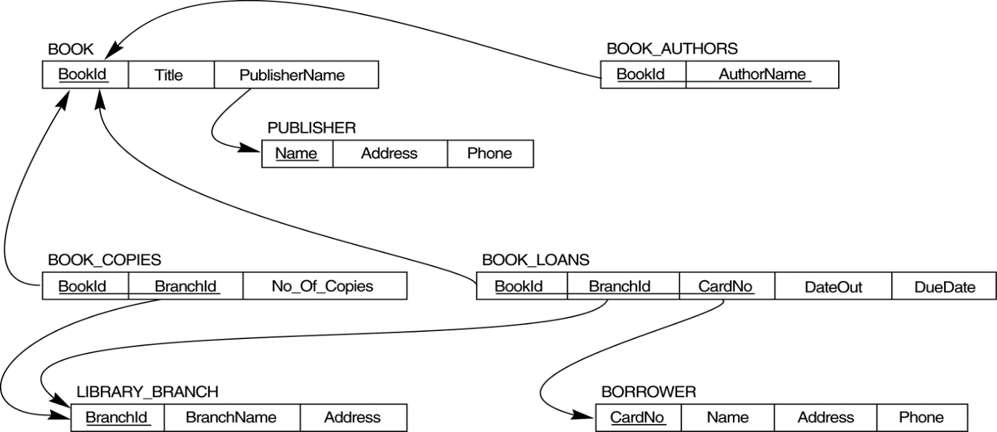

**Library**

1. Write a query to count the number of ‘S’ in the word ‘MICROSOFT SQL SERVER SERVICES SESSION’.

select len('microsoft sql server services session')-

len(replace('microsoft sql server services session','s',''))

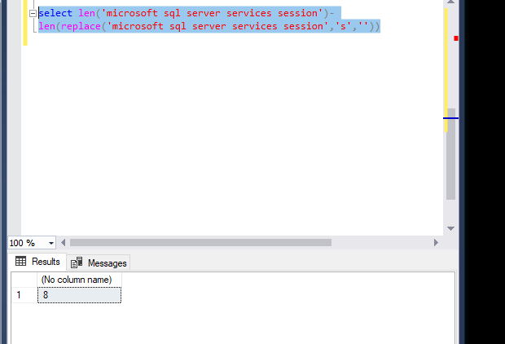

1. How many copies of the book titled ‘The Lost Tribe’ are owned by the library branch whose name is "**Sharpstown**"?

**Result set:** No_Of_Copies

select c.bookid,count(c.no_of_copies) as no_of_copies

from [BCMPLIB].[LIBRARY_BRANCH] l left join

[BCMPLIB].[BOOK_COPIES] c on l.branchid=c.branchid left join

[BCMPLIB].[BOOK] b on b.bookid=c.bookid

where l.branchname='Sharpstown' and b.title='The Lost Tribe'

group by c.bookid

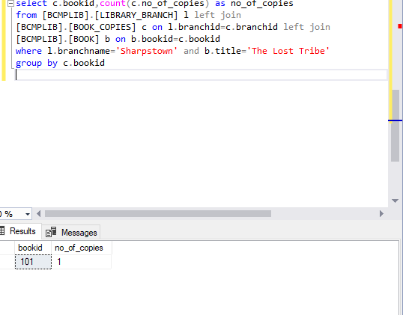

1. How many copies of the book titled ‘The Lost Tribe’ are owned by each library branch?

**Result set:** BranchName,No_Of_Copies

select l.branchName,c.no_of_copies as no_of_copies

from [BCMPLIB].[LIBRARY_BRANCH] l left join

[BCMPLIB].[BOOK_COPIES] c on l.branchid=c.branchid left join

[BCMPLIB].[BOOK] b on b.bookid=c.bookid

where b.title='The Lost Tribe'

1. Retrieve the names of all borrowers who do not have any books checked out. **Result set:** CardNo,Name

select b.name,b.cardno

from [BCMPLIB].[BORROWER] b full outer join [BCMPLIB].[BOOK_LOANS] l

on b.cardno =l.cardno

where l.bookid is null

or

select cardno,name from [BCMPLIB].[BORROWER]

where cardno not in (select cardno from [BCMPLIB].[BOOK_LOANS])

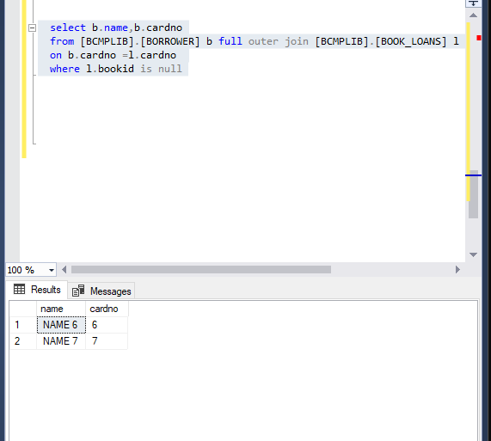

1. For each book that is loaned out from the "Sharpstown" branch, retrieve the book title, borrower's name, borrower's address , borrower's Phone format as (xxx-xxx-xxxx), Due date Format the date as (March-10-2010) and Count of days between the Dateout and Duedate as ‘No of Days For Due date’.

**Result Set:** Book Title, Borrower’s Name, Borrower’s Address, Borrower’s Phone, Due Date, No Of Days

select b.title,

br.name,

br.address,

format(cast(br.phone as bigint),'000-000-0000') as phone,

format(bl.duedate,'MMMM-dd-yyyy') date ,

datediff(day,bl.dateout,bl.duedate) as count_days

from

[BCMPLIB].[LIBRARY_BRANCH] lb

join

[BCMPLIB].[BOOK_LOANS] bl

on lb.branchid=bl.branchid

join [BCMPLIB].[BOOK] b

on b.bookid=bl.bookid

join [BCMPLIB].[BORROWER] br

on br.cardno=bl.cardno

where lb.branchname='Sharpstown'

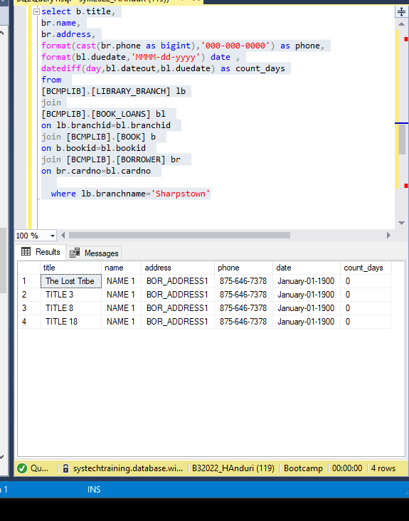

1. For each library branch, retrieve the branch name and the total number of books loaned out from that branch.

**Result Set:** BranchName, Total Books Loaned

select lb.branchname,count(*) as total_books_loaned

from

[BCMPLIB].[LIBRARY_BRANCH] lb join [BCMPLIB].[BOOK_LOANS] bl

on bl.branchid=lb.branchid join

[BCMPLIB].[BORROWER] b on b.cardno=bl.cardno

group by lb.branchname

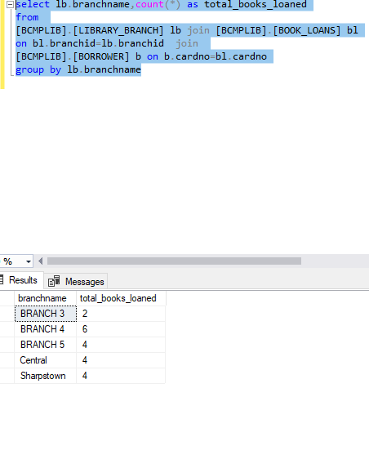

1. Retrieve the names, addresses, and number of books checked out for all borrowers who have more than three books checked out.

**Result Set**: Name, Address, No of Books

select lb.branchname,b.address,count(*) as total_books_loaned

from

[BCMPLIB].[LIBRARY_BRANCH] lb join [BCMPLIB].[BOOK_LOANS] bl

on bl.branchid=lb.branchid join

[BCMPLIB].[BORROWER] b on b.cardno=bl.cardno

group by lb.branchname,b.address

having count(*)>3

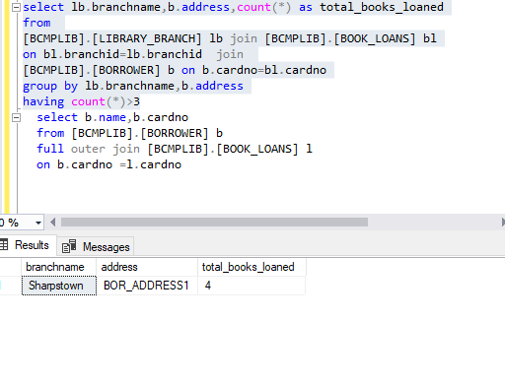

1. For each book authored by "Stephen King" **or co-authored with "Stephen King"**, retrieve the title and the number of copies owned by the library branch whose name is "Central"or "Sharpstown".

**Result set:** Title, Number of copies

select bo.title,cp.no_of_copies

from

[BCMPLIB].[BOOK_COPIES] cp join

[BCMPLIB].[BOOK_AUTHORS] a

on cp.bookid=a.bookid

join

[BCMPLIB].[LIBRARY_BRANCH] b on b.branchid=cp.branchid

join [BCMPLIB].[BOOK] bo on bo.bookid=a.bookid

where a.authorname='Stephen king' and

b.branchname in ('sharpstown','central')

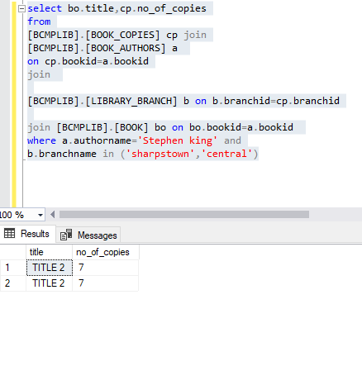

Retrieve the names of all borrowers, branch and the count of books that has been checked out in the month of January and restrict the result whose count of books is greater than 2 and order by desc

**Result Set:** Name, Branch, Count of Books

select b.name,lb.branchname,count(*) k

from [BCMPLIB].[BORROWER] b

join [BCMPLIB].[BOOK_LOANS] l

on b.cardno=l.cardno

join [BCMPLIB].[LIBRARY_BRANCH] lb

on lb.branchid=l.branchid

where month(dateout)='1'

group by b.name,lb.branchname

having count(*)>2

order by k desc

